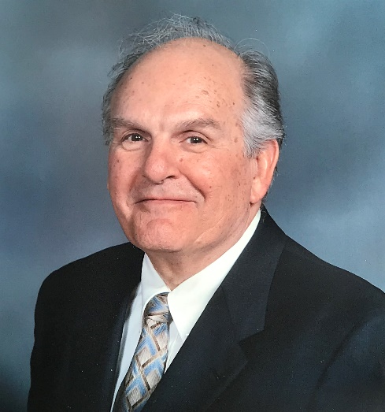
Professor Dean T. Mook, August 3, 1935 – June 19, 2020 (photo courtesy of D. Joseph Mook)

On June 19, 2020, the mechanics community lost one of its pioneers, Professor Dean T. Mook. He was 84.

Professor Mook was one of the most prolific mechanicians of his time. He was a singularly-talented passionate, and much beloved educator for over five decades. His research and teaching interests were truly multidisciplinary, they spanned the fields of fluid mechanics, solid mechanics, and dynamics. He applied his knowledge and expertise over a span of fifty years to educate generations of students about structural dynamics, nonlinear aeroelasticity, hydrodynamic stability, ship hydrodynamics, nonlinear dynamics, perturbation techniques, unsteady aerodynamics, aircraft stability and dynamics, and aircraft control.

Professor Mook was born in Ridgeway, Pennsylvania on August 3, 1935. He received his BSc and MSc degrees in Engineering Mechanics from Virginia Tech in 1958 and 1960. Upon earning his PhD also in Engineering Mechanics from the University of Michigan in 1966, he returned to his alma mater to start a very productive career. He combined broad and deep knowledge of different fields with unique communication skills to effectively advise more than 50 graduate students, write over 100 journal articles, and develop and teach over twenty undergraduate and graduate courses. He generously continued to support and teach many other students after his retirement in 2003, both at Virginia Tech and other institutions. Professor Mook was a brilliant and prolific writer. He co-authored the famous “Nonlinear Oscillations” book with the late Ali Nayfeh. Through his appointments at the Air Force Office of Scientific Research and the Office of Naval Research, Professor Mook left his mark on the field by developing new research initiatives and directions.

I was very saddened to hear about Professor Mook’s passing and I am still not able to process this news. No memorial tribute of a few paragraphs would be adequate to thank Dr. Mook for his contribution to my education, career, and life and no doubt those of countless others, but I nevertheless feel that I should try to write a few words out of respect.

Very few people have impacted my life as much as Professor Mook. I met him as a young undergraduate student in 1988 by attending his Introduction to Nonlinear Dynamics seminar when he was visiting us at the Universidad Nacional de Córdoba. His glowing enthusiasm for the subject was contagious, and his warm personality was unique, always supportive, and inspired self-confidence in all the students who met him.

In 1994, when I embarked on my PhD, I was very fortunate and privileged that Dr. Mook became my advisor. During that time, he was my mentor and friend. Thankfully, Professor Mook’s supervisory role never actually ceased at the completion of his students’ academic degrees. He continued to support me in my scientific pursuits, as well as in other aspects of life, ever since. Without exaggeration, I can say that Professor Mook left his mark on every stage of my career. It has been said that, as a general rule of thumb, there are at least five people that one will meet during the course of their life that will have a lasting impact on them and for me the late Dr. Mook was one of these five.

When I think about Dr. Mook I see his warm, friendly, and contagious smile. He was a wise teacher and great mentor and role model. He loved sharing his knowledge through collaboration, teaching, and conversation. Professor Mook was always supportive of friends and colleagues and had a wonderful sense of humor. He was singularly bright and confident, but also open and humble. He was both a lecturer and a listener. When we talked, he always made me feel I had something to offer. He was without a doubt the most observant, attentive, and knowledgeable man I have ever met.

His scientific achievements are well known, but above all, what distinguished him from many scholars was his ability to connect with everyone. He had this rare ability to bring out the best in people. He appreciated people for who they are. I will always remember Dr. Mook for his brilliant intellectual curiosity, his caring interest in my family and career, and his passion for science and history. A serendipitous discussion with Professor Mook could brighten your day, and an email from him was a source of encouragement and inspiration. He was a genuine gentleman, a dear friend with great empathy, and he had a big, big heart.

I had the fortune to have a personal relationship with him over the last twenty-five years and I can only describe it as a life changing experience. Our friendship was one that stretched across the seas, from the USA to Argentina and way beyond. We saw each other many times over the years; I was able to visit him in Blacksburg almost every year and he visited Córdoba and stayed at our home several times. I feel lucky to have had the chance to work closely with him and to have had the privilege of meeting some of his close friends and colleagues who, along with Dr. Mook, became important role models for me.

Over the years, we had multiple opportunities to collaborate and maintained a productive partnership that resulted in several publications. In 2017, our collaboration was pivotal to receiving the “Ingeniero Luis A. Huergo” Prize from the Argentinean Academy of Engineering, which is awarded to an “engineer who has demonstrated originality and impact in engineering.”

Moreover, Professor Mook made important contributions to the development of applied mechanics in my country through personal interactions with many Argentinean colleagues and students. The Fourth Pan American Congress of Applied Mechanics (PACAM IV), which he co-chaired in Buenos Aires in 1995, was a breakthrough meeting in terms of overall attendance and multidisciplinary outreach.

Foremost, Professor Mook was a scholar. Yet, what I will always remember and treasure was his excitement about my work, which seems minor compared to his significant contributions to the field. Dr. Mook would not just approve of your idea--he would embrace it with a passion for it even deeper than your own. I will never again hear him say “What a good idea! It is so good that it appears to be mine!” But, whenever I have an idea, the words will echo in my mind and remind me of him.

We have been blessed to have had Dr. Mook in our lives; to work with and to learn from, as well as to be able to pass his teachings on through our own research and mentorship of others. When the world needs it most, a great light has gone out. Professor Mook will live on forever in my heart as well as in the hearts of so many others he has influenced. He will be missed more than words can express.

